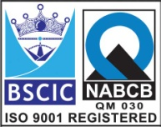****

**“EASCO” Lug Type Butterfly Valve Gear Operated**

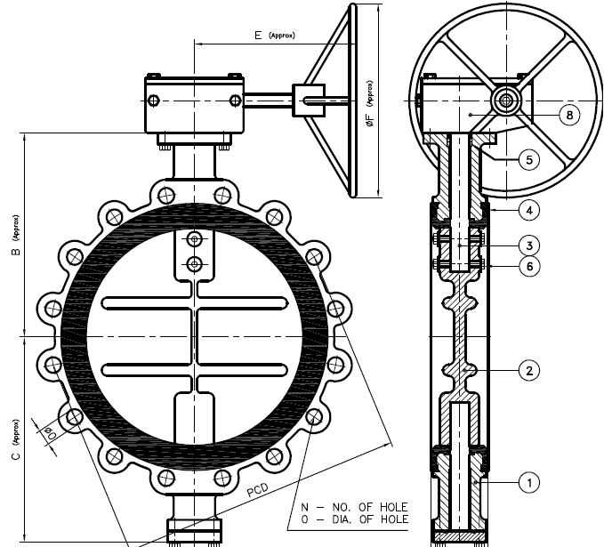

**Features: -**

* Zero Leakage
* Leak Tight Shut Off
* Lower Torque
* Smooth Operation & Installation
* Long Life
* Available in PN10 / PN16

**Testing Standard: - BS 6755**

|  |  |  |
| --- | --- | --- |
| Test Pressure in PSIG | | |
| Test | Hydrostatic | Hydrostatic  PN 16 |
| Pr. Rating | PN 10 |
| Body | 340 | 425 |
| Seat | 230 | 300 |

**Part List: - Standard Dimension (150#): -**

|  |  |  |  |  |  |  |  |  |  |  |  |  |  |
| --- | --- | --- | --- | --- | --- | --- | --- | --- | --- | --- | --- | --- | --- |
| **No.** | **Part Name** | **Materials** |  | **Size** | **200** | **250** | **300** | **350** | **400** | **450** | **500** | **600** |  |
| 01 | Body | IS 210 Gr. FG 200 / Ductile Iron  A 216 Gr. WCB / CF8 / CF8M | L | 60 | 68 | 78 | 92 | 102 | 114 | 127 | 154 |  |
| B | 230 | 266 | 300 | 320 | 385 | 405 | 465 | 540 |  |
| 02 | Disc | IS 210 Gr. FG 200 / Ductile Iron  A 216 Gr. WCB / CF8 / CF8M | C | 156 | 196 | 230 | 272 | 302 | 325 | 405 | 460 |  |
| E | 285 | 285 | 285 | 300 | 305 | 305 | 370 | 350 |  |
| 03 | Stem | AISI 410/304/316 | ǾF | 300 | 300 | 300 | 350 | 500 | 500 | 500 | 600 |  |
| 04 | Body Seat (Liner) | Neoprene / EPDM / Nitrile / Silicon / Viton / Other Request | PCD | 298 | 362 | 432 | 476 | 540 | 578 | 635 | 749 |  |
| 05 | Gland Seal | Neoprene / EPDM / Nitrile / Silicon / Viton / Other Request | N | 8 | 12 | 12 | 12 | 16 | 16 | 20 | 20 |  |
| 06 | Disc Lock Pin | SS 304/316 | ǾD | 22 | 25 | 25 | 29 | 29 | 32 | 32 | 35 |  |
| 07 | Gear Box | Worm & Gear Type | ISO  5211  Flange | F07 | F10 | F10 | F12 | F14 | F14 | F16 | F16 |  |
| 08 | Fasteners | CS / SS304 / SS316 |  |  |  |  |  |  |  |  |  |  |
|  |

**Due to continuous development Program, the design & data given in this leaflet are subject to change without prior notice.**

**ANITA ENGINEERING WORKS**



58-59, Narayan Estate, Opp. Shree Ram Estate, Nr. CMC Ltd. Odhav, Ahmedabad-382415, Gujarat, India

Phone: +91 79 22974101, Fax: +91 79 22875014

Email: eascovalves@gmail.com, eascovalves@yahoo.com, Web: [www.eascovalve.com](http://www.eascovalve.com)